**DevOps Project: CI/CD Pipeline with Jenkins, Docker, and Azure (Open Source)**

**Overview**

This project demonstrates a full DevOps pipeline:

* Code from GitHub
* Build using Jenkins (Maven)
* Dockerize and push to Docker Hub
* Deploy to Azure VMs

**Tech Stack**

* **Azure** for infrastructure
* **Jenkins** for CI/CD
* **Docker** for containerization
* **GitHub** for source control
* **Maven** for Java build

**Steps**

1. **Create the Main VM in Azure**

* OS: Ububntu 22.04
* Open Ports: 22(SSH), 8080(Jenkins)

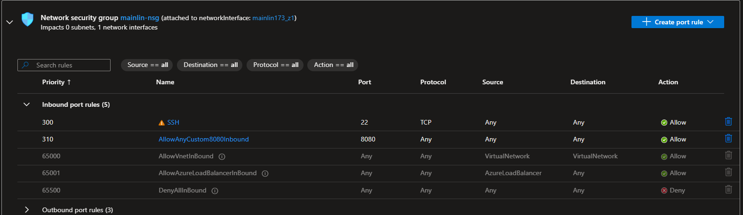

1. **Install and Setup Jenkins with Maven Plugin**





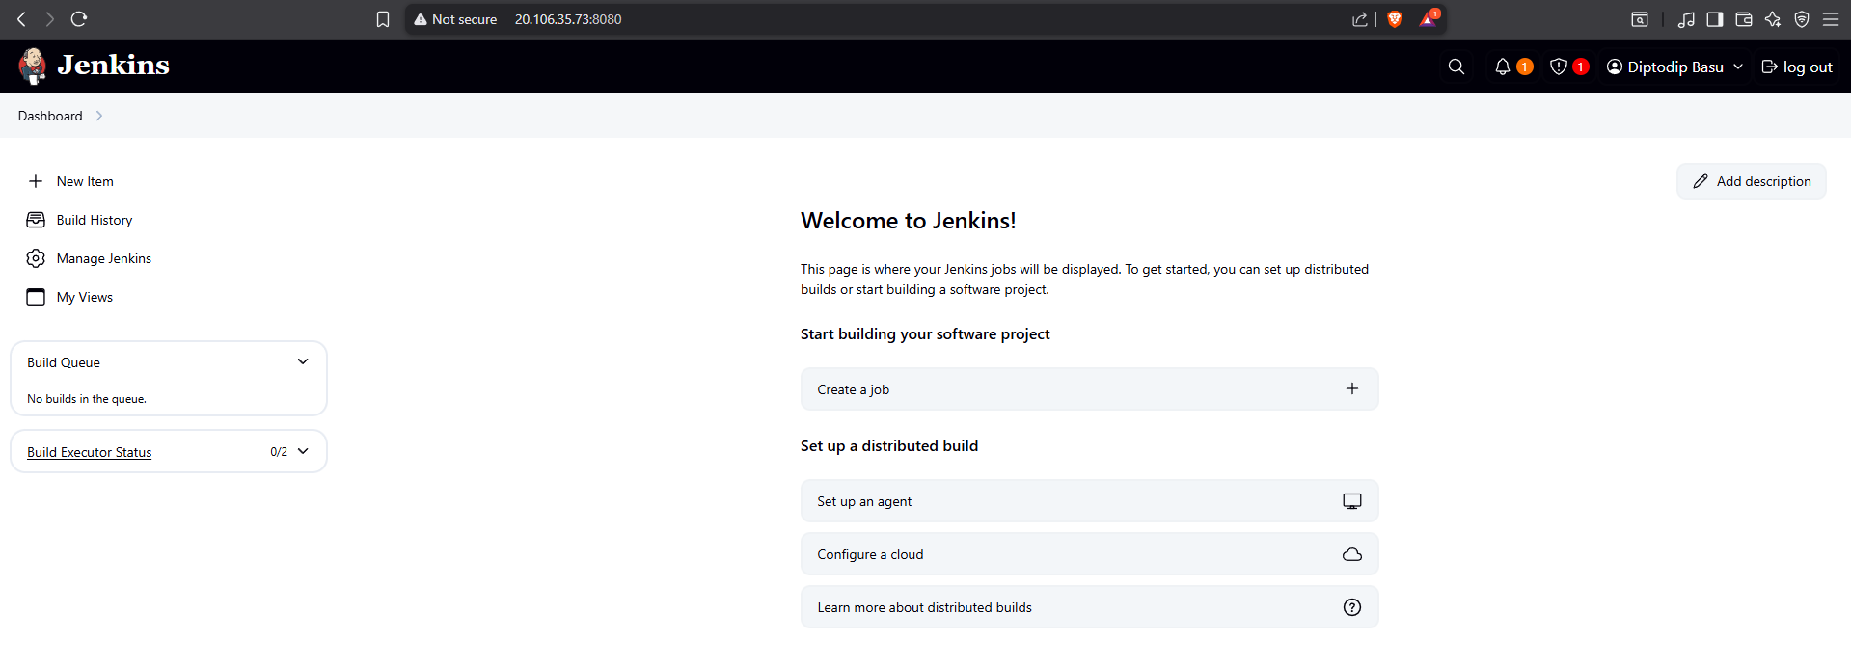

1. **Create Jenkins Pipeline**

* Source: GitHub
* Build: Maven
* Add Docker build Script

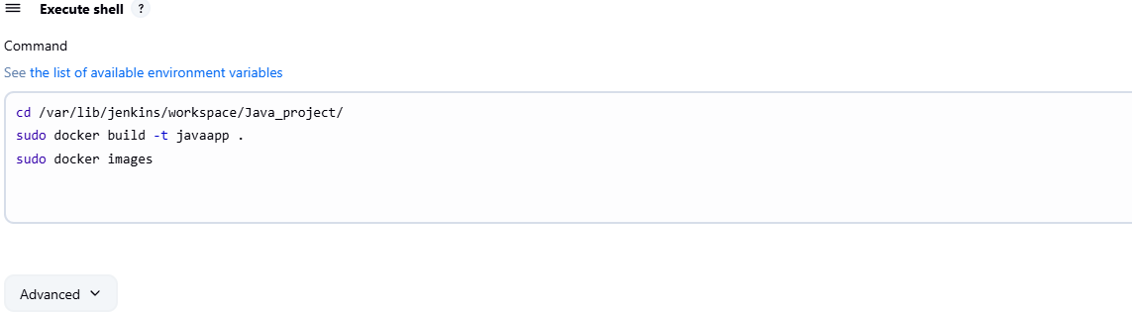

* Confirm JAR file creation

1. **Install Docker on the Main VM**

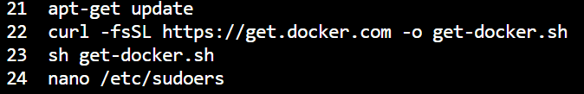

1. **Push Docker image on docker hub**

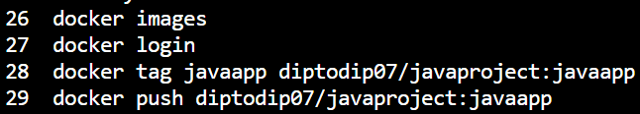

1. **Launch a new VM**

* OS: Ububntu 22.04
* Open Ports: 22(SSH), 8080(View Website), 80(http)

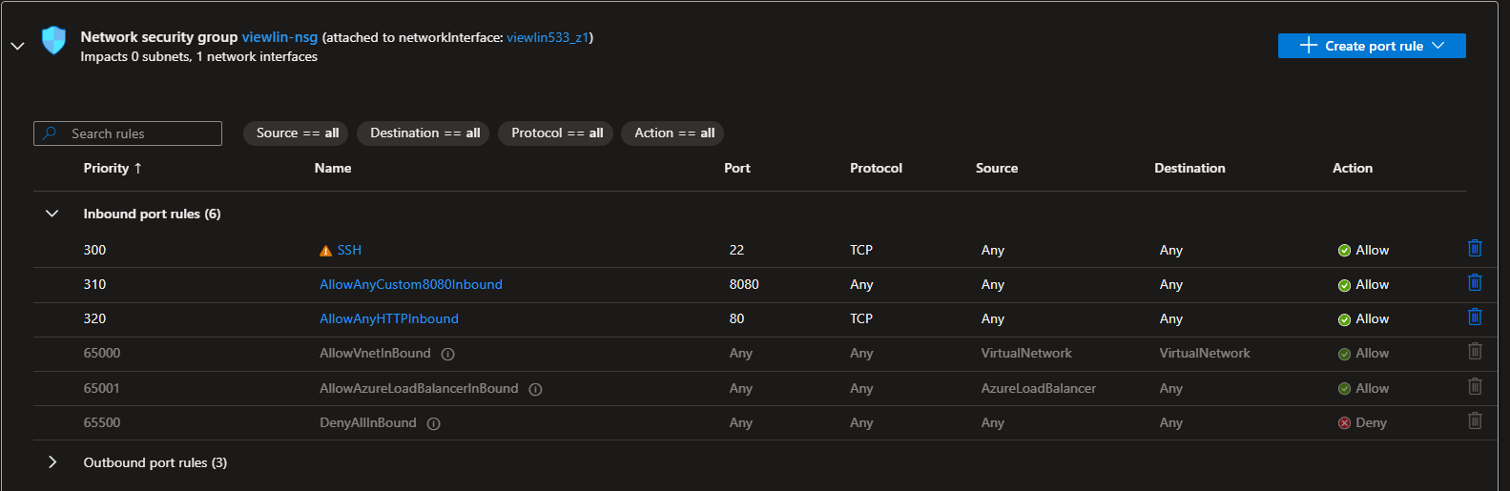

1. **Pull and Run Docker Image**

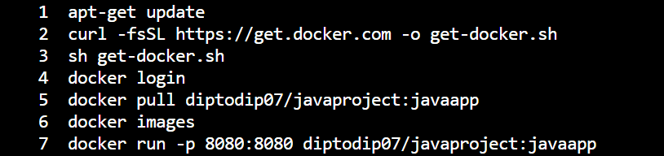

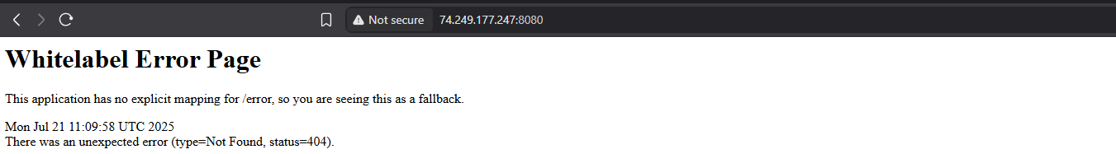

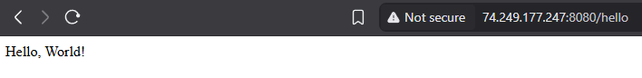

**Outcome:**

The application runs successfully on a second VM via a pulled Docker image.



**Resource Group:**

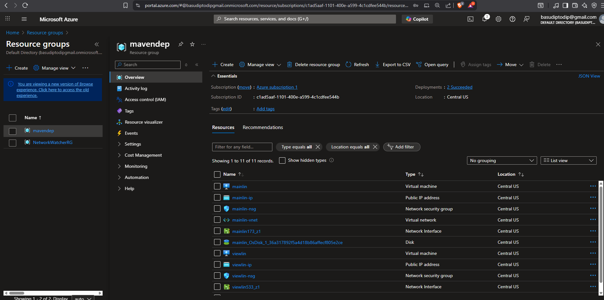

**Github repo structure:**

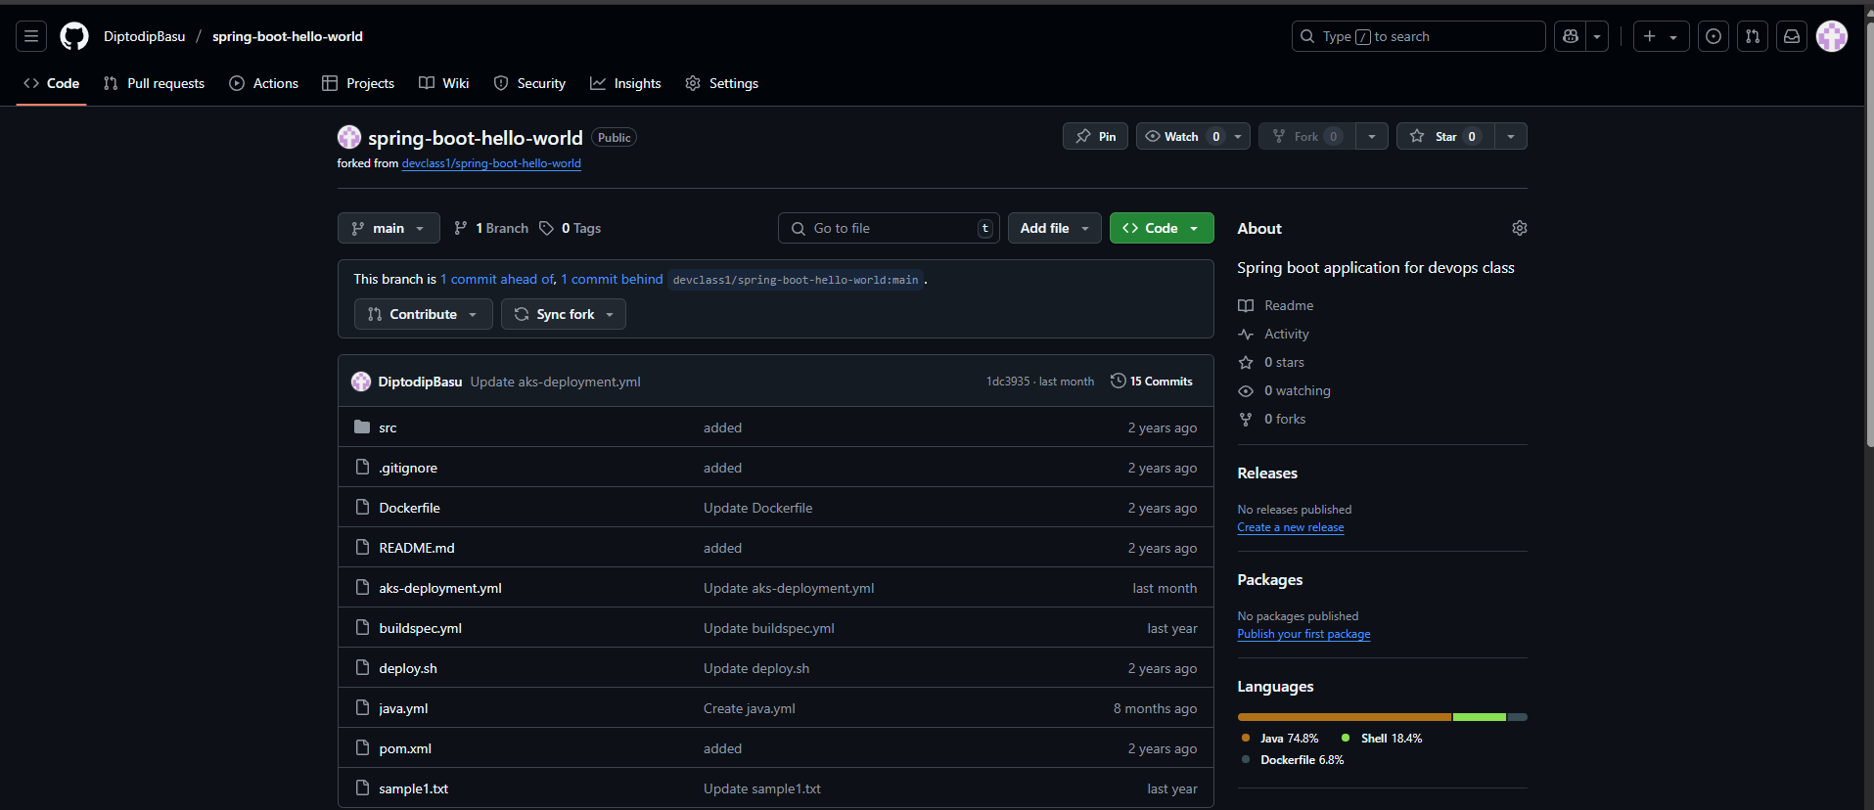

**Jenkins dashboard and pipeline success:**

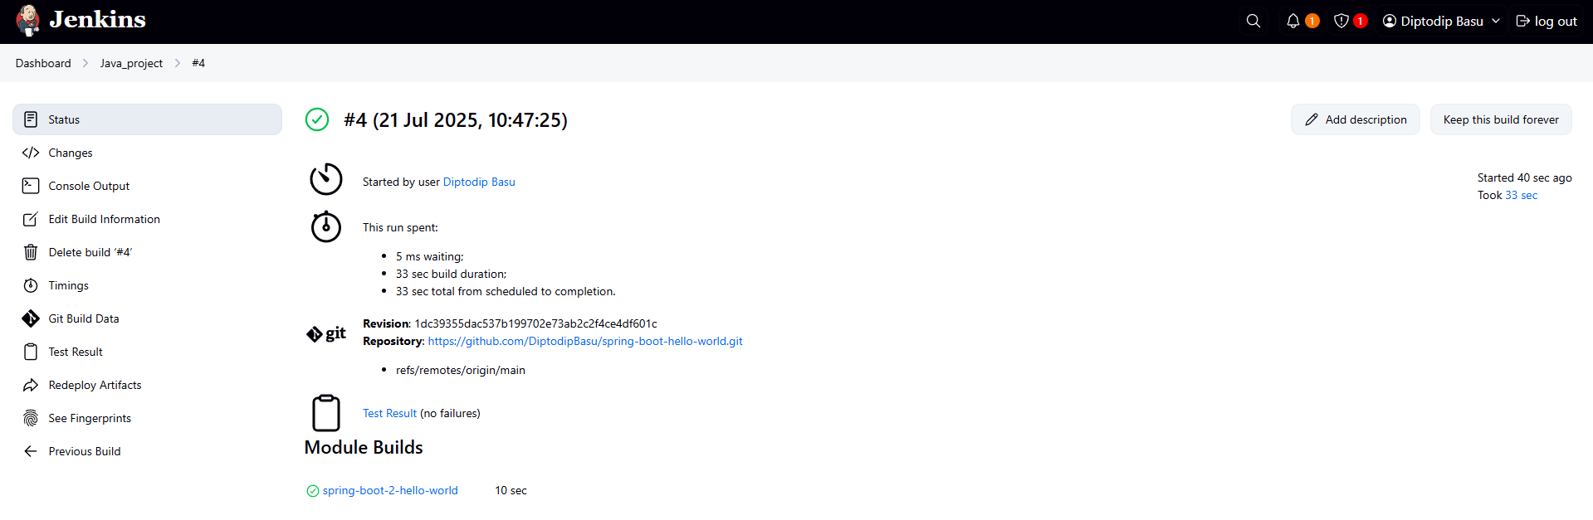

**Docker image pushed to Docker Hub:**

